**Covid**

**Code:**

*################# Transforming Covid Data #################*

*library(reshape2)*

*library(xlsx)*

*covid <-read.xlsx("C:/Users/Malik/Documents/GitHub/Data-Visualization-Data502/exam1part2/covid.xlsx",1)*

*covid_melted = reshape2::melt(covid,id.vars="State", measure.vars=c(4,5), value.name="value")*

*write.csv(covid_melted,"C:/Users/Malik/Documents/GitHub/Data-Visualization-Data502/exam1part2/covid.csv")*

**Screenshot:**

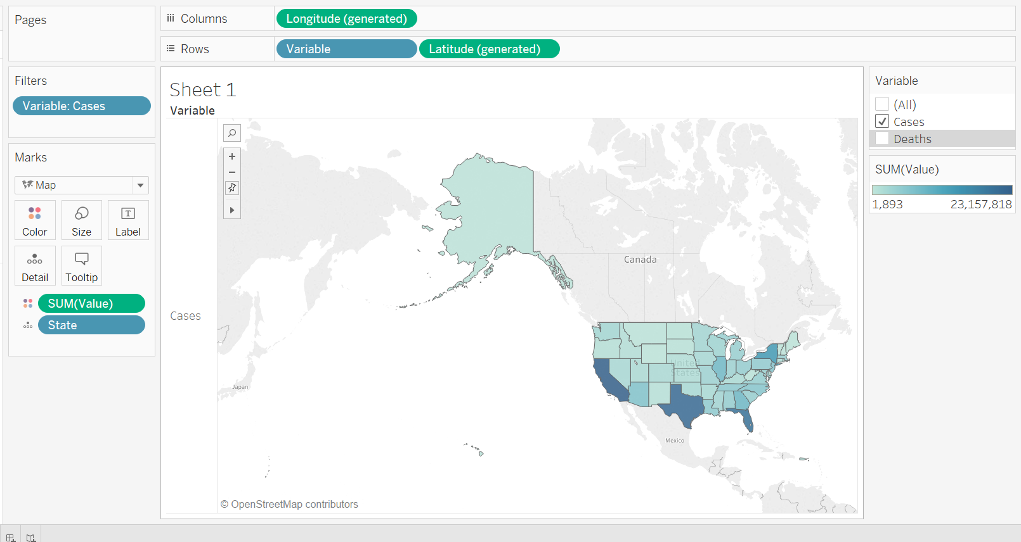

**Observation:**

Deaths are Higher in New York. Cases hare Higher in California, Texas and Florida. But their deaths are less in number than New York. These places are the outlier in term of both number of cases and number of deaths. On the other hand, most of the states are blow such extremes numbers.